Aim: - Study of Social Engineering Attack using Kali Linux on or

before.

Software Required: -

Kali Linux, Metaspoitable

Outputs: -

Step 1: - Open SET Took Kit

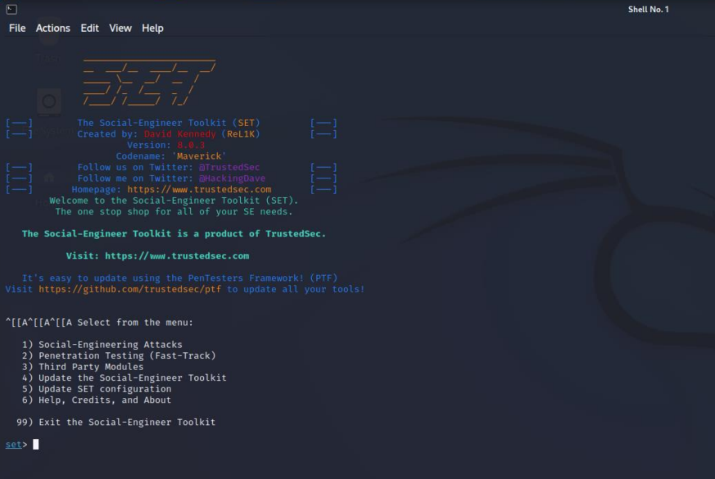

Step 2: -

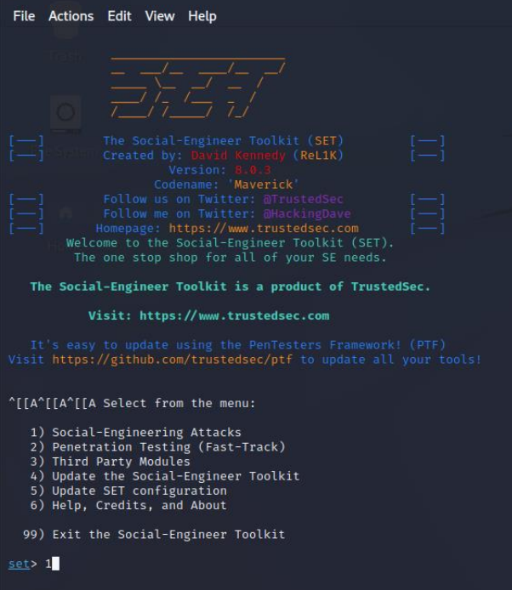

Step 3: -

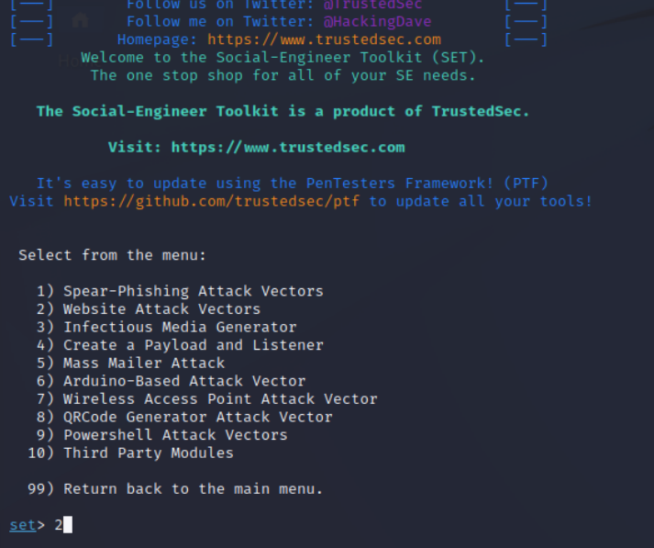

Step 4: -

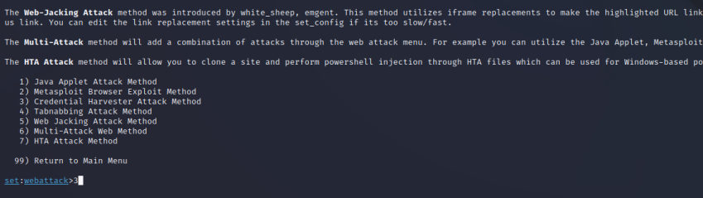

Step 5: -

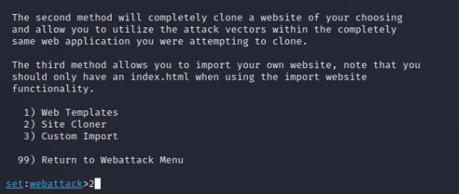

Step 6: -

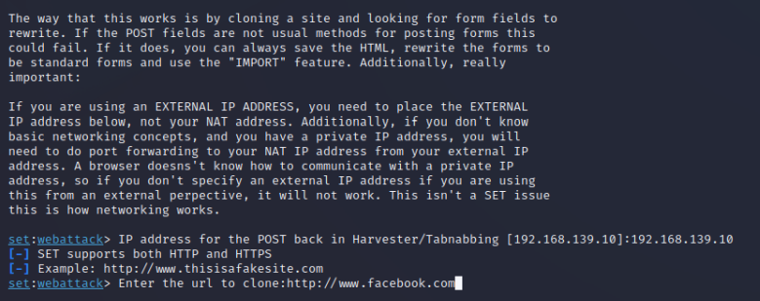

Step 7 -

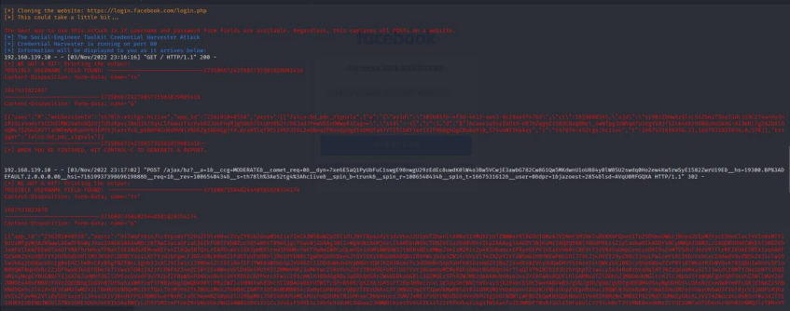

Step 8: -

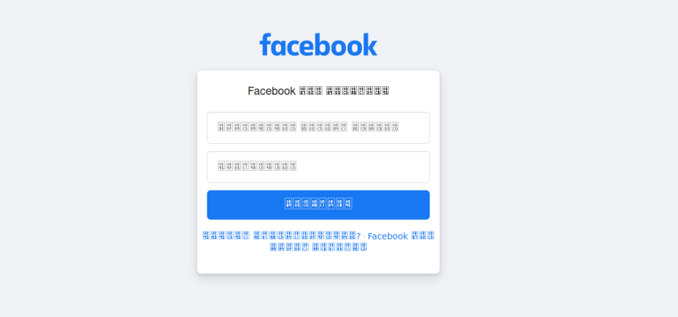

Step 9: -

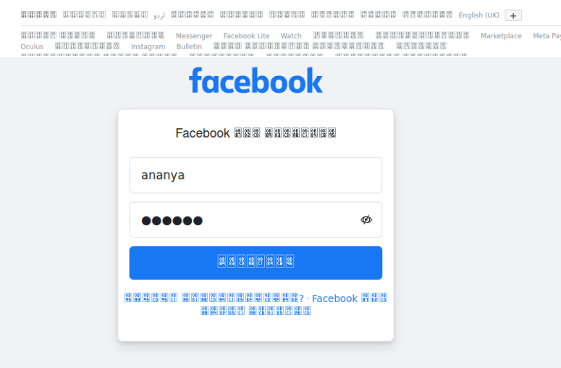

aryan

Username - aryan

Password - aryan, for checking harvesting and sniffing.

Step 10: -

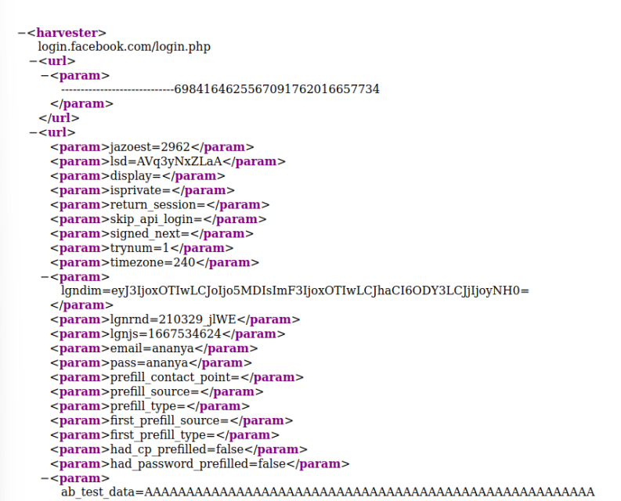

Social Attack, Website Attack, Harvest, Web Template: -

Step 1: -

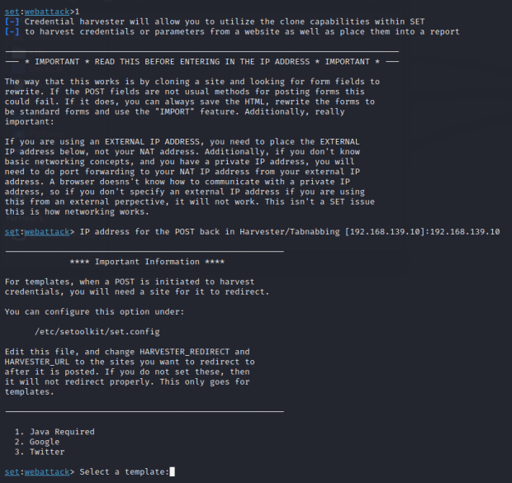

Step 2: -

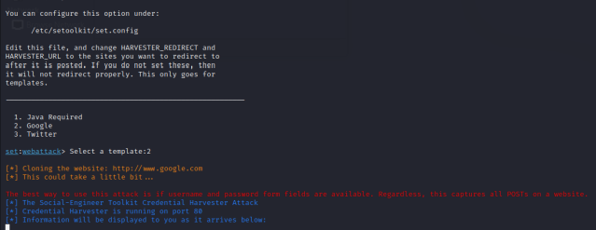

Step 3: -

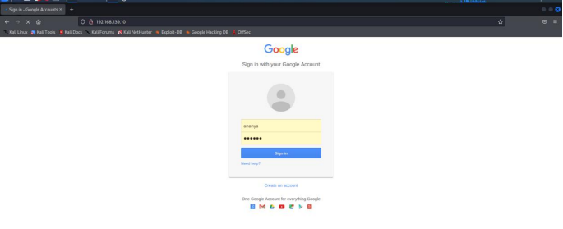

Step 4: -

In file manager -/root/.set/

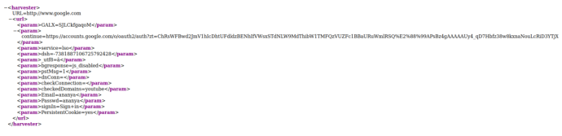

Result: -

Successfully verified and understood the concepts of password sniffing and social engineering attacks.